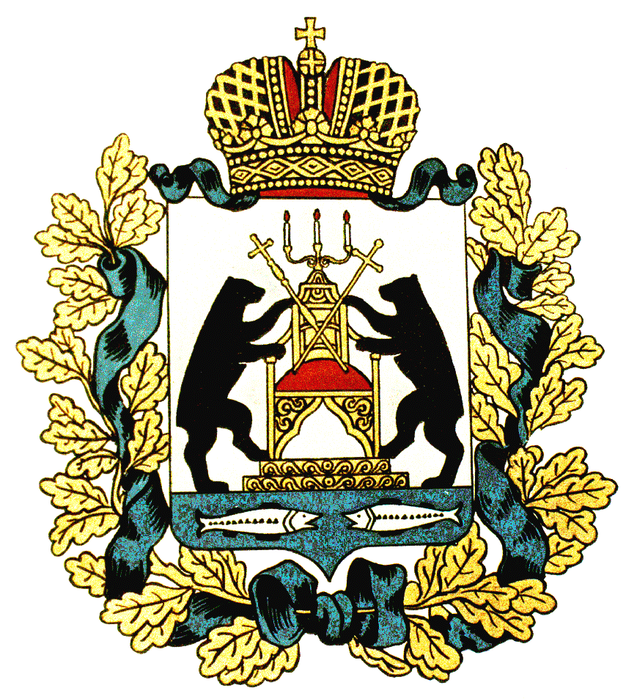 | PASSPORT OF NOVGOROD REGION
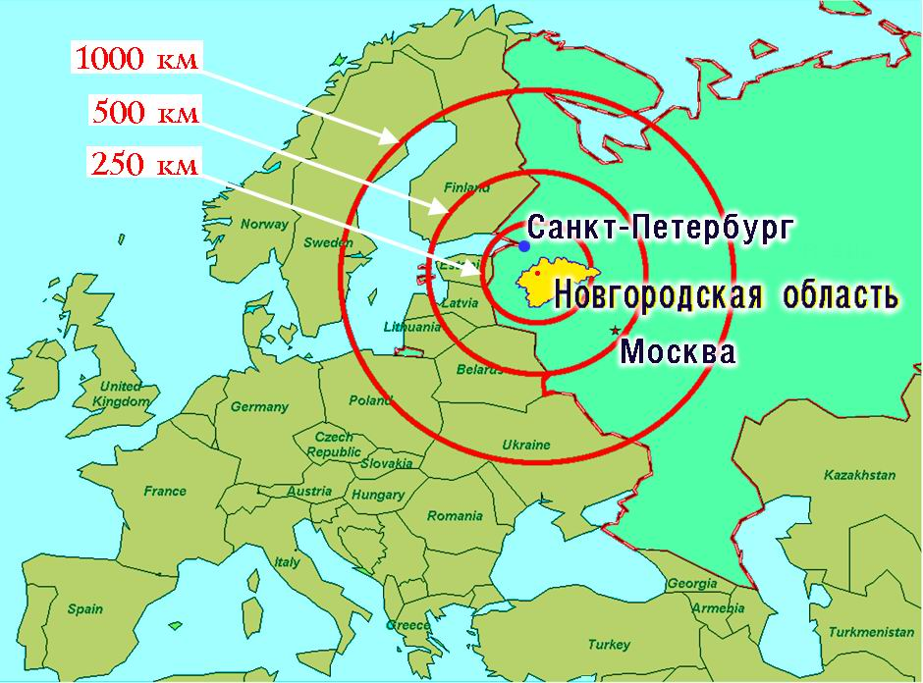
The Novgorod region (oblast) is located in Northwestern Russia and has an advantageous geographical location between the two largest Russian business centres. The region is located in close proximity to ports, airports and customs terminals.
Territory - 54, 5 thousand km².
Population - 618,7 thousand (as of
January 1st, 2015).
The administrative centre – Veliky Novgorod – is located 550 km from Moscow and 180 km from St. Petersburg.
The region is situated in the Northwestern Federal District and borders on Pskov, Tver, Leningrad and Vologda regions.

Cultural heritage and tourist potential
– Veliky Novgorod – historical centre of the Russian state founded in 859 A.D.
– 4, 8 thousand cultural heritage objects (including unique memorials of medieval architecture with icon painting and frescoes), among them:
393 monuments of federal significance,
37 monuments and architectural complexes located in Veliky Novgorod and its surroundings enrolled on the UNESCO Register of the World’s Cultural Heritage Monuments
– archeological objects
more than 2,1 thousand objects dating to the Mesolithic Era and post-medieval settlements
– valuable museum and library deposits
– recreational resources
The Valdai national park, campsites, recreation sites
– rehabilitation resources
mineral and radon springs, medicinal mud of the «Staraya Russa» spa

Science
The Novgorod region boasts a number of centres for scientific research, research and development companies and associations:
- АО «Research-Production Enterprise «Kvant»
- OAO «R&D Company «Start»
- OAO «Scientific-Research Institute for Industrial Television «Rastr»
- ZAO « R&D Company «PLANETA - ARGALL»
- OAO «Research and Development Corporation «Precision Instruments System»
- OAO "Experimental Design Office Planeta"
- Federal State Unitary Enterprise «Special Design-Technological Bureau «Omega»

Education
- The State Educational Institution of Higher Vocational Education "Yaroslav-the-Wise Novgorod State University" (NovSU)
- 9 branches of other higher educational institutions
- 13 vocational schools
- 9 schools of primary vocational training
- 216 secondary schools, lyceums and high schools
Basic Raw Materials
- Timber – the main natural treasure of the region (forests cover over the half of the region’s area).
- Peat.
- Construction raw materials - quartz and mason’s sand, boulder, sand, gravel, carbonate rock, refractory clay.
- Mineral and fresh underground water.
- Refractory clay, quartz sand, mineral underground water and medicinal mud are of both regional and federal significance.

Size of Permanent Population (as of the beginning of the year, thousand people)

Workforce potential
The number of people in employment in the region (as of the 1st quarter of 2015) totals
314, 8 thousand (95,5 % of economically active population).

Transport system
- the total regional rail transport network totals 1144 km;
- the total road network is 11 thousand km;
- the length of the region’s navigable waterways totals 608 km.

Communication
The modern communications network is up to world standards:
- Automatic telephone connection with all regions of Russia and all countries of the world.
- Digital communication channels connect all the municipalities with the region centre.
- Cellular communication – all major Russian providers offer their services.

Gross Regional Product (billion RUR)

Breakdown of Gross Regional Product in 2014 (%)
Industry
Key economic sectors of the Novgorod region:
- Chemical industry
- Woodworking industry
- Food industry
- Engineering (machine-building) industry
- Ferrous industry
- Electric power industry
Export sales amount to more than 31 percent of total sales, these are mostly chemical and timber products.
Competitive products:
- Mineral fertilizers
- Refractory products and proppants
- Steel pipeline valves
- Nonferrous metals
- Heat insulators
- Optical aids
- Lumber
- Woodchip board
- Plywood
- Cabinet and upholstered furniture
- Confectionery

Agriculture
The major crops grown in the region are potatoes, vegetables produced in the fields and under glass, grains, common flax and forage crops. The major segments of commercial livestock farming include pig meat and poultry production, egg and milk production, as well as raising beef breeds of cattle.
External economic activity
- Foreign trade partners – companies from more than 92 countries
- Foreign trade turnover in 2014 – USD 2057,8 million:
exports share – USD 1292,0 million;
imports share – USD 765,8 million
Foreign investments
As of January 1st, 2014, the share of accumulated foreign investments in the regional economy totaled USD 2125 million, with foreign direct investment amounting to USD 1763,75 million.
In 2015, the region's economy received investments from 23 countries. Major investing countries were Canada, Finland, Netherlands, Ireland and Germany. The amount of their investments totaled USD 274.9 million, which is 72,6% of all foreign investments to the regional economy.
As of January 1st, 2015, 356 enterprises and companies from 49 countries with foreign capital participation operated in the Novgorod region.
Such notable companies as Kraft Foods, AMCOR, UPM Kymmene, StoraEnso, Dresser Industries, Pfleiderer, Meusburger, Benteler, Uralita, IKEA Industry conduct investment activities in the region, thus creating awareness about the territory as one of the most investment attractive areas in Northwestern Russia.
Yearly breakdown of foreign investments:
 | 2000 | 2005 | 2007 | 2008 | 2009 | 2010 | 2011 | 2012 | 2013
Million USD
Total Investments | 49.5 | 279.1 | 295.9 | 371.8 | 378.2 | 533.0 | 384.7 | 477.5 | 378.5
including:
Direct Investments | 19.7 | 178.7 | 125.3 | 265.1 | 159.8 | 164.6 | 16.2 | 111.0 | 146.8
Other investments | 29.8 | 100.4 | 170.7 | 106.8 | 218.3 | 368.1 | 368.4 | 366.5 | 231.7
of which:
trading investments | 16.2 | 95.9 | 96.3 | 78.5 | 145.0 | 60.1 | 48.2 | 52.6 | 70.8
other investments | 13.6 | 4.5 | 64.8 | 28.3 | 73.3 | 304.7 | 320.3 | 305.9 | 160.9
of which international financial institutions loans | 12.7 | - | 20.4 | 21.6 | 37.0 | - | 2.8 | - | -
other | - | - | 9.6 | - | - | 3.4 | - | 8.0 | -

Economic sectors showing considerable promise for investments
The following priority areas for investment have been identified in the Regional Development Strategy 2020:
- Agro-industry
- Extraction and processing of the common useful minerals (including alternative fuels)
- Housing development and production of building materials
- Innovative sector
- Engineering sector (including auto components production)
- Food industry
- Electronic engineering industry
- Pharmaceutical production
- Timber harvesting and timber processing
- Transport (including water transport)
- Tourism sector

Novgorod Region Investment Regulations
Investment Strategy 2020, which stipulates both sectoral and territorial aspects of the strategic trends and priorities for promoting investment-driven development of every municipal district and the region as a whole, has been adopted in the Novgorod region (Governor Decree as of 20.03.2015 № 90). The Investment Strategy 2020 Implementation Plan envisaging tools and actions for raising the region’s investment attractiveness has been approved for the period of 2015-2017 (Governor Decree as of 20.03.2015 № 89).
The Investment Declaration of the Novgorod region establishing major interaction principles between executive branch authorities and legal entities, which grants non-worsening the region’s business climate, has been adopted (Governor Decree as of 23.09.2013 № 302).
The auxiliary program «Raising Investment Attractiveness of the Novgorod Region» has been adopted within the framework of the State Programme «Development of Innovation and Information Technologies in the Novgorod Region for 2014-2020» approved by the Novgorod Region Government Regulation as of 27.10.2013 №327. The main objective of the Programme is creating conditions for raising investment attractiveness of the Novgorod region.
Plan for Creating Investment Objects and Infrastructure Facilities in the Novgorod Region for 2014 and for the period of 2015-2017 has been adopted (The Order of the committee for innovation and information technologies of the Novgorod region as of 27.08.2014).
Regional Law as of 11.06.1998 №29-OZ «On Investment Activity in the Novgorod Region and Investors’ Rights Protection» envisages essential norms and regulations for investors including mechanisms for investment activity support.
Special organization for promoting investment attractiveness and recruitment of investors – the state regional autonomous institution «Agency for the Novgorod Region Development» – has been established and operates today in the Novgorod region.
Government Regulation as of 26.08.2014 №448 stipulates coordination procedures for interaction between the region’s executive branch authorities and other parties of investment activity in the investment sector. The Regulation establishes mechanisms of interaction between all region-level government structures in all areas of investment activity on a "one contact" principle basis, envisages possible forms of support for investment projects, provides procedures for obtaining state support for investors and stipulates terms and sequence of actions between the region’s executive branch authorities and the Agency for the Novgorod Region Development, beginning with a date of the investor ‘s initial application and ending in a date of the investment object substantial completion.
Government Regulation as of 18.02.2014 №101 «On Evaluation of the Regional Regulations and Expert Reviews of the Regional Laws» stipulates procedures for evaluation of all new regional legal acts and regulations regarding investment and entrepreneur activities. In 2014, evaluation of 82 draft regulations and examination of 2 regional legal acts were provided in the region.
Today, Council for Investment Climate Improvement under the Governor of the Novgorod region has been establishes and operates in the region.
Investment Portal http://econominv.novreg.ru provides information about investment activity in the Novgorod region including Plan for Creating Investment Objects and Infrastructure Facilities, the information on investment legislation and the database of the investment sites, projects and business offers.
Public company «Novgorod Region Development Corporation» was established in 2014 for the purposes of solving practical problems in the investment sector.
In accordance with the current regional regulations, companies implementing investment projects approved by the regional government are provided privileges for the taxes to be paid to the regional budget, including corporate profit tax, corporate property tax and transport tax.
Today, the companies implementing investment projects approved by the Government of the Novgorod region are provided the following tax benefits during the payback period (but not longer than the calculated payback period):
- property tax exemption
- 50 percent reduction of transport tax rate
- preferential rate of 13,5 percent for corporate profit, which is the minimum acceptable for corporate profits tax rate in accordance with the Federal legislation
Local municipalities are entitled to provide land tax and land rent incentives.
Business entities registered and conducting business activities in Batetsky, Volotovsky, Maryovsky, Parfinsky and Poddorsky municipal districts are granted partial reimbursement of expenses relating to the production and sales of goods (works, services), which amounts to 83,3 percent of corporate profits tax paid to the regional budget. They are also exempt from corporate property tax. According to the municipal legislation, the above-mentioned business entities are granted land rent incentives.
The committee for Innovation and information technologies of the Novgorod region is an administrative body with performs work on attracting and effective use of domestic and foreign investments.
Head of the committee: Vladimir M. Karpunin
Address” 173005, Veliky Novgorod, pl Pobedy-Sophiiskaya 1
Tel.: +7(8162)76 56 36
Fax: +7(8162)73 28 28
E-mail: kiit@niac.ru
Website: http://it.novreg.ru
Investment Portal of the Novgorod region: http://www.econominv.novreg.ru

